УДК 621.43
Требования к оформлению доклада в сборник трудов конференции
Инициалы и фамилии авторов
Организация
Simulation of pneumatic start of piston engine
Yu.A. Grishin, N.S. Malastovskii, V.S. Semenchukova
Bauman Moscow State Technical University
В начале статьи в левом верхнем углу ставится индекс УДК. Далее данные идут в такой последовательности: инициалы и фамилии авторов; полное название статьи; на русском и английском языках — не менее 120 слов аннотация (должна включать в себя: актуальность, постановку проблемы, пути решения поставленной проблемы, результаты и выводы); ключевые слова — понятия и термины используемые в статье (5–10 слов); текст статьи; список литературы.
Ключевые слова: ключевые слова — понятия и термины используемые в статье (5–10 слов). Например: пусковая система, поршневой двигатель, математическая модель, программа расчета пуска.
Providing a reliable run-up is a relevant task of the reciprocating engine development . Pneumatic start systems are applied for running-up the marine and middle or high power cargo engines. Calculation methodology for in-cylinder processes combined with the dynamics of an engine acceleration is observed. Program based on a Euler numerical method is implemented. It allows to analyze the pneumosystem parameters influence on the engine characteristics.
Кeywords: starting system, reciprocating engine, mathematical model, program for calculating a run-up of the engine.

The structure of the report (article) should contain the following elements: introduction, review of work with formulation of the research task, the proposed solution, analysis of the results obtained, conclusion.
The length of the article is from 5 to 10 pages.
The article should be completed in text editor Word 2010. The text should be written with 1.5 line spacing, font size 14, Times New Roman, on one side of the sheet with margins of width 2.5 cm without blots and inserts. Paragraph indentation should be the same throughout the text - 1.25 cm. Quotes (""); brackets ([ ], ()); dash - large (-) in the text; Small (-) in a digital combination (1-5, 1996-1998, etc.). Numbering of pages is required. In the article it is necessary to make references to tables, figures and literature sources presented in the paper. Footnotes (automatic) should only be used in the end. Transfer is automatic only.
As an object of study, an engine of the type 12V 26.5 / 31 [1, 3] is considered (Table 1).
Table 1
Engine Parameters
Parameter | Value
Piston Stroke, S, (мм) | 310
Cylinder bore, D, (мм) | 265
Mean effective pressure, $p_{e}$, (МПа) | 2,58
Rated power, $N_{e}$, (кВт) | 4410

Original drawings should be in formats .tif, .jpg, .bmp, .pdf, .eps with a resolution of 300 dpi. Color drawings (diagrams, photographs, computer windows, etc.) are preferred. All figures must be numbered and provided with captions. For example:
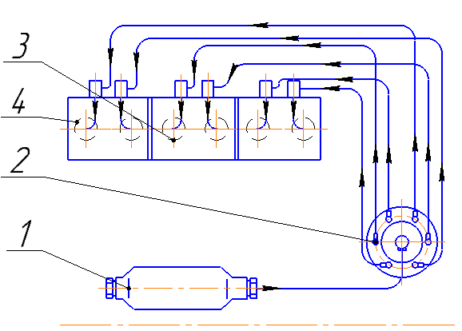
Fig. 1. Starting system
The use of pseudo-graphics, the production of drawings, drafts and photographs of bad quality is not allowed.
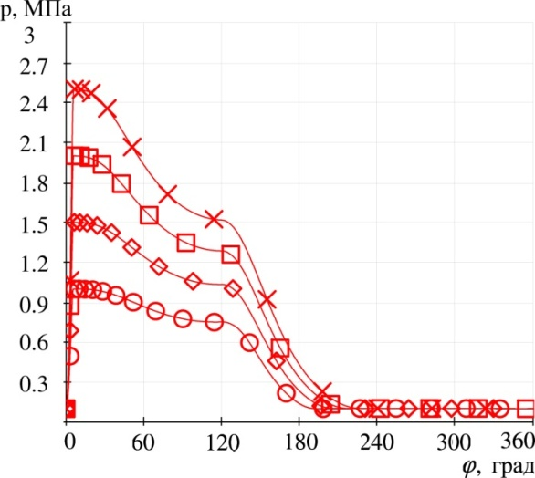 | 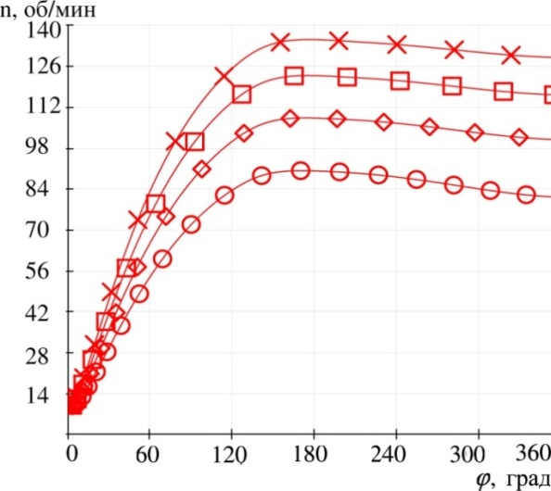
P_{пн}=2.0 МПа, P_{пн}=2.5 МПа, P_{пн}=1.0 МПа, P_{пн}=1.5 МПа
Fig. 2. Dependence of pressure in the cylinder and the speed of the crankshaft on the pressure in the pneumatic system
Formulas are typed in the text editor MS Word. The letters of the Greek alphabet are typed in normal type; letters of the Russian alphabet in the formulas (including in the indices) - normal, Latin - in italics. For example:
$M_{сопр}= F_{т}∙R=μ\left\{N\frac{c_{m}}{ω}+K\left[r_{1}\frac{ω_{2}}{ω}+\left(r_{2}+r_{3}\right)\left(1±\frac{ω_{2}}{ω}\right)\right]\right\}$ ,
where $μ$ – coefficient of friction, $N=P_{Σ}\tan{β}$ – normal force of piston pressure on the surface of the cylinder of the engine, $β=arcsin⁡(λ∙\sin{α})$ – angle of connecting rod, $P_{Σ}=p∙D+P_{j1}$ – total force acting on the piston, $P_{j1}=m_{пд}Rω^{2}\cos{α}$ – first-order inertia force, $m_{пд}$ – mass of the translationally moving parts, $R$ – crank radius, $c_{m}=\frac{S∙n}{30}$ – piston speed, $ω_{2}=\frac{dβ}{dt}$ – angular speed of connecting rod, $r_{1}$ – piston ring radius, $r_{2}$ – cran radius, $r_{3}$ – radius of crankshaft journal, $K=\frac{P_{Σ}}{\cos{β}}$ – force acting along the axis of the connecting rod.
The article should use the system of international units (SI).
Abbreviations should be defined when they are first mentioned in the text, except for abbreviated units of measurement, physical, chemical, technical and mathematical quantities and terms (units are given in Russian).
According to the results presented, conclusions must be made.

Literature:
The list of references is compiled in the sequence of references in the text. In the text of the article, references are enclosed in square brackets. For articles, the author's surname and initials, the title of the article, the name of the journal, the year, volume, number (or issue) and the page numbers on which the corresponding article was published are indicated. The list of literature should include links to current scientific work of domestic and foreign specialists, primarily articles published over the past 5 years in peer-reviewed (indexed) scientific periodicals. It is not recommended to reference material from textbooks, teaching aids or popular science literature. In the list of references, it is desirable to specify at least 15 references to scientific articles from journals, while unjustified self-citation should be avoided.
Example of list of references:
[1] Тарасов В.А., Бараев А.В., Филимонов А.С., Боярская Р.В. Конструкторско-технологические основы унификации параметров цельнометаллических баллонов высокого давления в ракетно-космическом машиностроении. Вестник МГТУ им. Н.Э. Баумана. Сер. Машиностроение, 2014, № 5, с. 70–84.
[2] Васильев В.Н. Организация производства в условиях рынка. Москва, Машиностроение, 1993. 368 с.
[3] ГОСТ 23945.0–80. Унификация изделий. Основные положения. Москва, Стандартинформ, 1991. 7 с.
[4] Антонов Г.А. Основы стандартизации и управления качеством продукции. Санкт-Петербург, Изд-во СПБУЭФ, 2011. 684 с.
[5] Семенов Г.Е. Разработка процессно-ориентированного подхода к моделированию организационно-технологических видов деятельности в производственных системах. Дис. … канд. техн. наук. Москва, 2003. 144 с.
[6] Касаев К.С. ред. Новые наукоемкие технологии в технике: Энциклопедия. Т. 12. Технологическое обеспечение сложных технических систем. Часть 1. Москва, ЗАО НИИ «ЭНЦИТЕХ», 1998. 396 с.
[7] Aeronautics and space within the Air Liquide Group (2009) URL: http://www.airliquide.com/file/otherelementcontent/pj/dp%20juin%2009%20ven55801.pdf (дата обращения 2 ноября 2014).
[8] Семенов Г.Е. Методика конструктивно-технологической отработки газодинамических систем изделий РКТ. Тез. докл. Междунар. молодеж. науч. конф. XXVI Гагаринские чтения, Москва, 11–15 апреля 2000 г. Москва, МАТИ, 2000, 237 с.
[9] Ryan Gehm. Scorpius Space Launch propels all-composite tanks forward. SAE International, 2008. URL: http://articles.sae.org/2866/ (дата обращения 24 ноября 2014).

